HOME | WHAT WE DO | GALLERY | FAQ
Logo | Search:
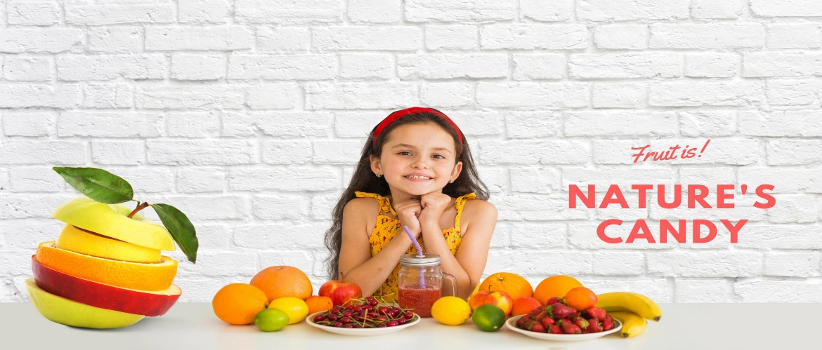
Fresh Fruits Online & Fresh Vegetables Online We're not your average fruit importers. We have expertise in sourcing the choicest of fresh fruits from around the world and distributing it across the length and breadth of India. Our top-notch distribution network strengthened through almost a century of existence in the fruit business, works efficiently to ensure the fruits are delivered far and wide with an intriguing depth of freshness. We provide fresh fruits online and fresh vegetables online. We have expertise in providing fresh fruits online and fresh vegetables online and offline and sourcing the choicest of fruits and vegetables from around the world.
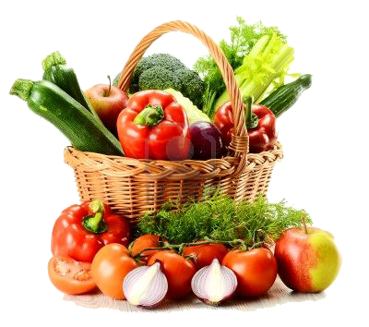 | 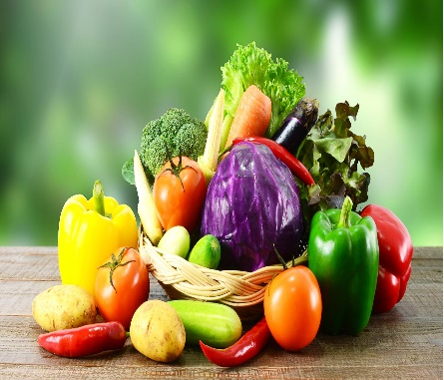
 | How dependable are we? Our experience and heritage within the fruit industry in the world is second to none as we have joined hands with well trained and experienced doctors. Keeping our roots intact, we represent the same passion for quality, service and values that we have built on all around the world. Today, we import fresh, wholesome and high quality fruits straight from the orchards of the farthest corners of the world, which has made us attract customers all around the globe.Click here to see our top ten lists of fruits for you
 | Email us | Our pictures | Our location
Facebook |  | INSTAGRAM | X
 Click here to order! |  | DESIGNED BY: DARLEY PRINCESS, SEPTEMBER 2023

